Star of the North

Annual Report 2022

The Star of the North Retreat House
3A St. Vital Ave
St. Albert, AB T8N 1K1
Phone: 780-459-5511
Email: admin@starofthenorth.ca
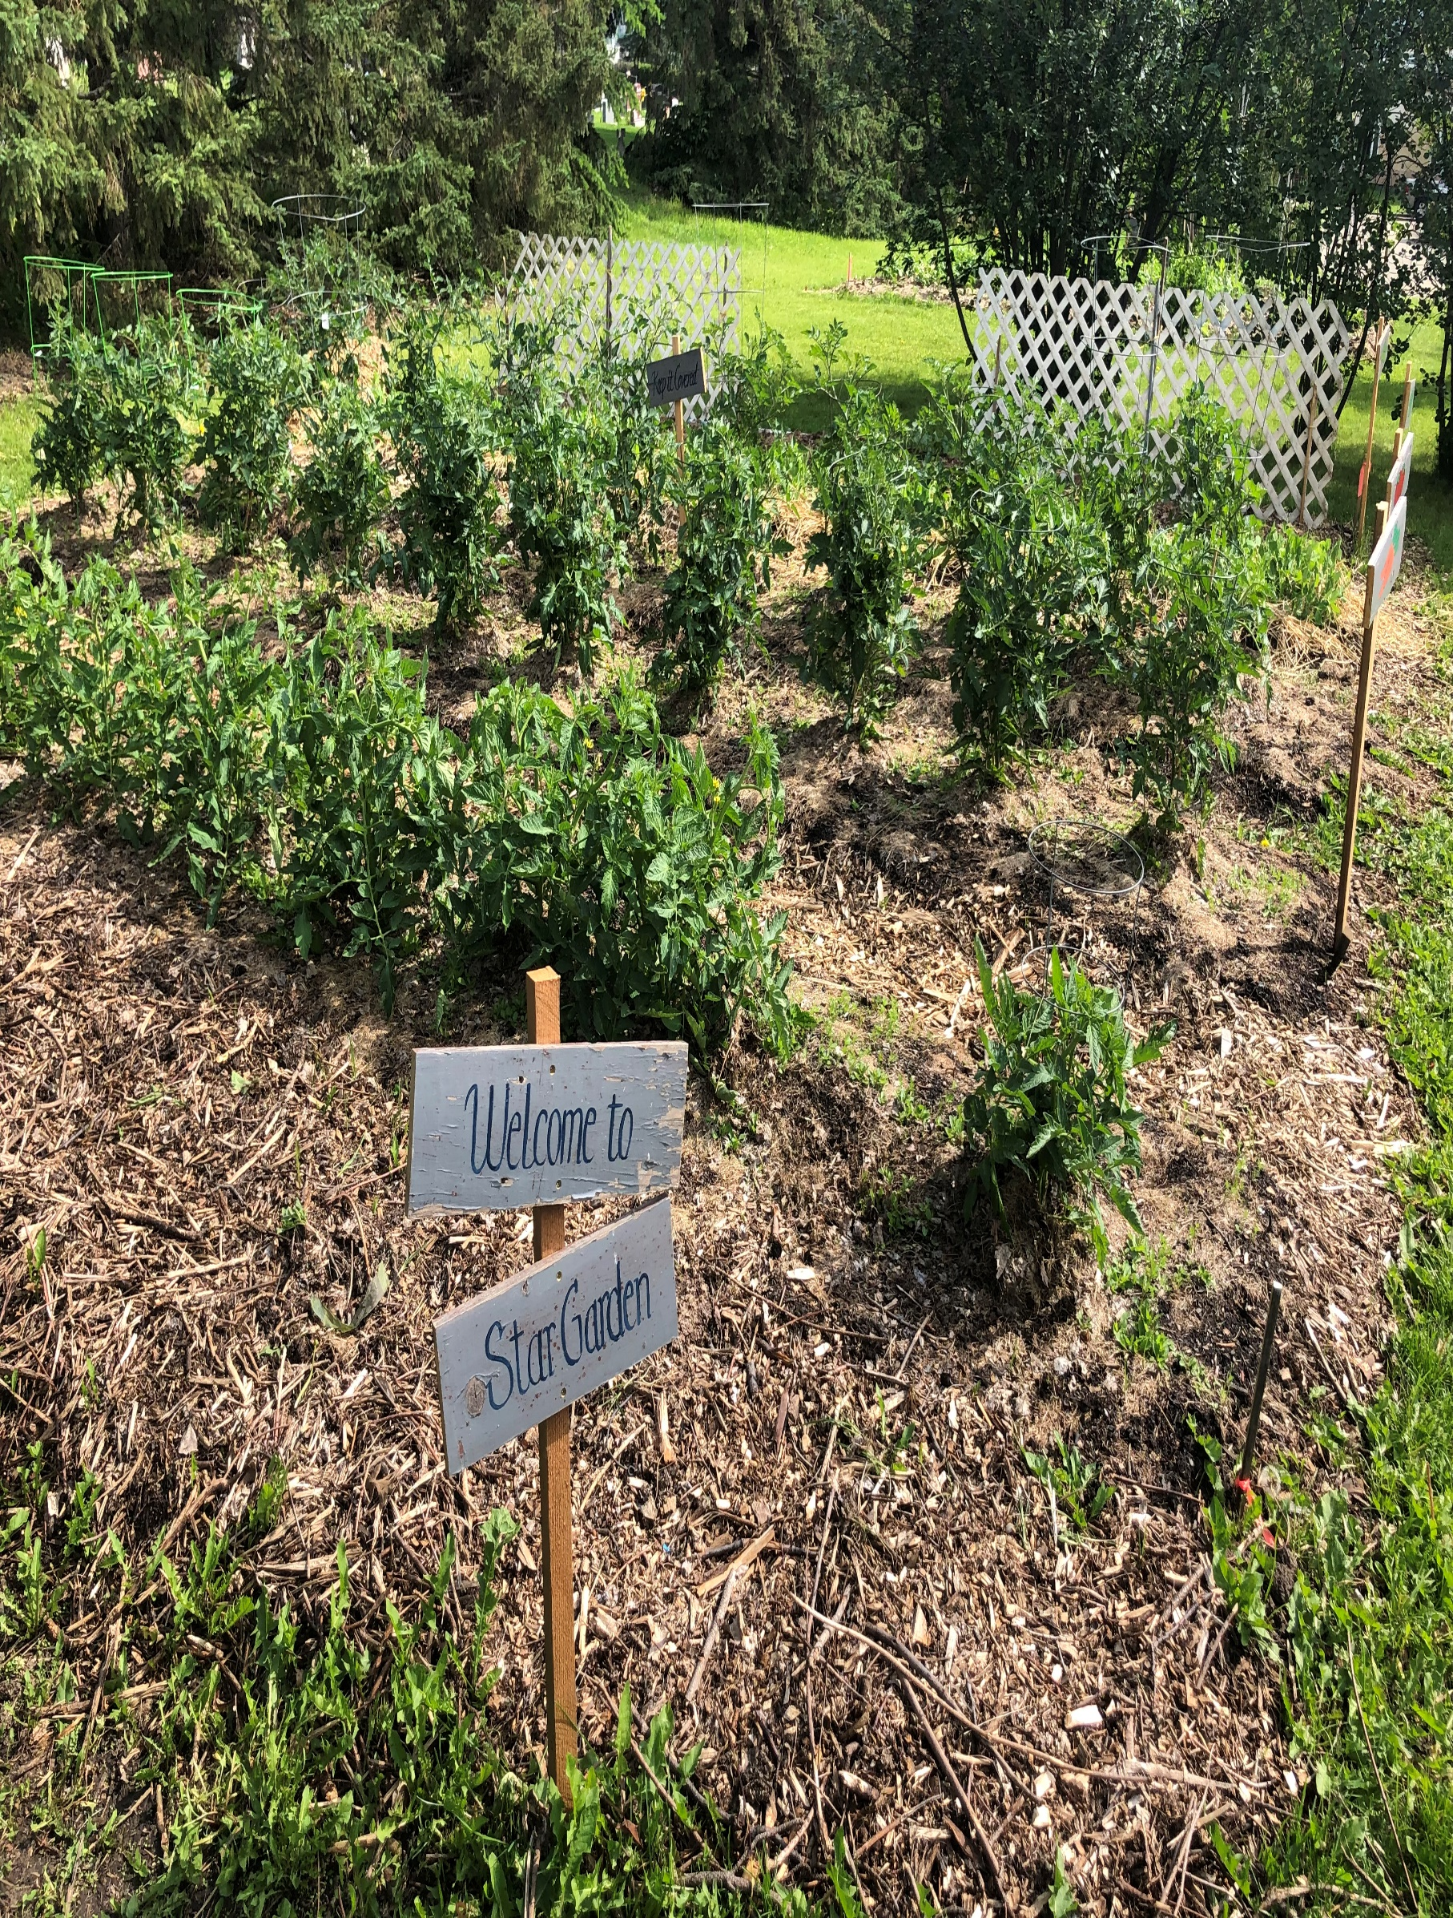
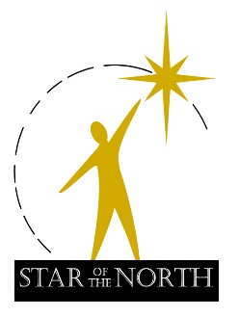

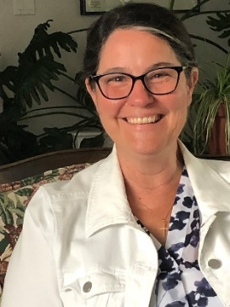
Director’s Message

Lucie Leduc

Overview of January to December 2022

“…I ask for God’s forgiveness and I want to say to you with all my heart: I am very sorry. And I join my brothers, the Canadian bishops, in asking your pardon.”

Pope Francis – April 1, 2022

One highlight of 2022 for The Star of the North, was hosting the indigenous peoples of the Archdiocese of Winnipeg and the Jesuits for the Pope’s visit to Canada. For staff and for me personally, it was a journey of gently walking with others in our mutual woundedness and witnessing the humility of our leader, Pope Francis, as he bore with compassion the sufferings of all who gathered. The few days we shared as church with the world, were a powerful reminder of our purpose: to stay close to one another, to know that what is good for people is good for the earth, and to hold fast to our vision, mission, and values.

We saw a weary, sad, and anxious people arrive at The Star with a commitment to hear the man of God and the church they felt harmed and, in some ways, betrayed by. Waking up at 4am to drive to Maskwacis, and again to go to the Coliseum for mass the following day, these elders tirelessly sought out their healing and reconciliation. By the time they were getting on the bus for the long journey home, we saw softened, easier, smiling faces; people helping and serving one another, with a great deal more joy and peace than when they’d arrived. Whatever our journeys since then, we hold faith together in solidarity for a future of hope, joy, peace, and fullness of life.

Christ transcends barriers and boundaries bringing healing, peace, forgiveness to those who seek him. The Star shines and beckons seekers to find rest, to follow Christ, and to be Christ for the world. For months before and after the beautiful moment of the Pope’s visit we were doing the works we share humbly, with gratitude to the many Oblates and others before us who’ve made this sacred place of retreat possible. We celebrate with joy the services we had the privilege to provide in 2022: the hosted gatherings that are slowly returning post-pandemic, Aurora Living, The Star Garden, and the many other programs leading us to walk closer with others, to dialogue and to witness the abundance of grace on offer from Holy Trinity each day.

We give thanks for yet another year of healing, forgiveness, reconciliation, and growth in Trinitarian faith, hope and love for future generations.

Vision
- Awaken to Spirit – Transform the World

Mission Mission
- Offers a sacred space of hospitality and healing;
- Provides support and challenge for prophetic ministry;
- Awakens people to their personal dignity, beauty, and gifts;
- Engages the community in active evangelization, and the care of all of creation;
- Empowers people to grow in the service of others and the love of the Creator.

Values
- An environment for spiritual growth and prayer
- The wholeness and wellbeing of the person
- Silence, reflection, and contemplation
- Active listening and contemplative engagement
- Authentic witness to the gospel of Jesus Christ
- The diversity of human experiences and relationships
- The faith traditions and cultures of others
- The gift, dignity, and integrity of creation

Staff, Volunteers and Star Board of Directors 2022
Staff
The Star staff of 2021 stayed the course through to 2022, except for one significant loss. Sr. Mariangel Marco was called to be a member of the Ursulines of Jesus General Council in France and appointed to serve with her sisters working in Cameroon. She graciously committed to work with the Aurora Living program team till the first 3 year-round is complete in June 2024.
We had a staff retreat day in July 2022 with me and Mariangel facilitating the day. Half the day was dedicated to interacting with the seven goals of the Laudato Si platform. Staff were invited to reflect on each of the goals and to see how The Star might fit into each of them to improve our ecological footprint. The other half of the day was dedicated to team building and learning new skills for improving relations and communications. The day concluded with a staff gathering in honor of Mariangel’s time with us.
We added new kitchen and housekeeping staff in 2022. We welcomed Zarina Oliinyk from Odessa, Ukraine to Star housekeeping part-time, two days weekly or more when needed. We also welcomed Mary McGeown to the kitchen team, casual, part-time for cooking.
Added to Clint Porritt’s full-time Program Development and Communications role was the role of managing The Star’s Food Security Garden. Clint continues to work humbly and graciously providing food, both spiritual and tangible, for the good and growth of community at The Star.
Guest Facility Coordinator, Donna Radke, juggles finance/administration with reception and Guest Services Coordinator roles to welcome and care for the needs of all who call or come to our doors. She ably provides a warm hospitality and service for groups and individuals seeking to take advantage of The Star’s sacred environment.
Donna and Greg Ebert maintain security and housekeeping, making sure the facility is safe, clean, and welcoming. Gary Simpson provides contract hours to maintain annual facility maintenance and upkeep. Chef Crystalle Krukowski managed kitchen staff, scheduling, food purchasing with an ordered, skillful patience while keeping the viable financial oversight. Beth Tolentino, Lucia Rolden, and Meg Oechslin and Mary McGeown serve as part-time, casual kitchen cooks and assistants.
The Star staff is a faithful and committed team working together for the good of community.
Volunteers
Our volunteer community continues to maintain and create beauty for the front and rear yard. Thanks goes to Collette Oddleifson, Louise Seymore, Linda Winski, Bernie McCracken, and Br. Don Claerhout.
In-house volunteers are slowly returning as the need presents with new and old groups returning to The Star. They provide hospitality and a welcoming environment. Thank you to all our volunteers for their enduring, steadfast commitment to The Star.
Board of Directors
In 2022, there were no new appointments to the Board of Directors. The Star is blessed to have committed, engaged volunteer Board Directors who reflect a range of skill and ability for the good of The Star.
Sponsored Facility Programs
The Star of the North is a sacred place set apart for people to experience radical hospitality, peace, and rejuvenation. The Star endeavors to walk with others on the spiritual journey, to “Awaken to Spirit – Transform the World” and manifest the reign of God in our world.

The Program Team develops programs in the spirit of the Oblate charism and informed by the Catholic Church tradition. Retreats, workshops, and formation events align with our vision, mission, and values in service of the spiritual growth and well-being of people.

- Renewed relationship with God and faith community:
- Wilderness: From Slavery to Freedom (23pp)
- STN Ways of the Heart Women’s Retreat Oct 14, 2022 (23 pp)
- Synodal Church Nov 19/22 (25pp)

- Deeper prayer life through meditation and contemplative practice
- Bridges to Contemplative Living: Living Your Deepest Desires, Spring (13pp); Fall (16pp)
- Anamcara, June 5, 2022 (34pp); Nov 3-5/22, (40pp)

- Lifestyle of Gospel integrity through Catholic Social teaching and practice, Truth and Reconciliation
- The Cost of Colonialism: The Joy of Jubilee (24pp)
- Kisemanito Pakitinasuwin: The Creator’s Sacrifice Exhibit (30pp)
- Together We Heal – Feb 24, 2022 (40pp), April 21, 2022 (50pp), May 25 (47pp)
- Papal Visit May 18, 2022 (55pp)
- Reconciliation Through Justice, Sept 29, 2022 (33pp)
- Outcasts Who Belong, Nov 10/22 (25pp)
- Living the Psalms Nov 19/22 (23pp)

- Integral Ecology as expressed in Pope Francis’ letter to the world “Laudato Si” –
- Aurora Living Rituals and Modules 2 (19pp), 3 (15pp), 4 (19pp)
- Climate Hope Series – 3 evenings, monthly stand-alone events– Jan 40pp., Feb. 40pp., Mar. 30pp.
- Holy Ground: The Spiritual Act of Growing and Sharing Food, Series May-June, (9pp)
- Seasons of Creation, Sept 1, 2022 (25pp)

- Accompaniment for healing, forgiveness, and reconciliation on the spiritual journey, and Twelve Step
- Healing the Healers – Module 4: Jan 22, 2022 (24pp)
- Healing the Healers – Module 1, Mar 22, 2022 (21pp)
- Bereavement Support, May 10, 2022 (8pp)
- Spiritual growth in Gospel/liturgical l life
- Cheminer avec l’apôtre Philippe : French Retreat, Feb 4-6, 2022 (25pp)
- Lenten Retreat : Releasing the Paschal Power of the Cross, Mar 12, 2022 (17pp)
- Steve Bell Concert, Sept 23, 2022 (150pp)
- Advent Retreat Dec/22 (15pp)
- Ron Rolheiser Public Lecture Dec/22, (170); RR Retreat (79pp)

Note: “pp.” = people who attended both online and onsite – there is overlap of people, as seen above, in a variety of areas on the chart.

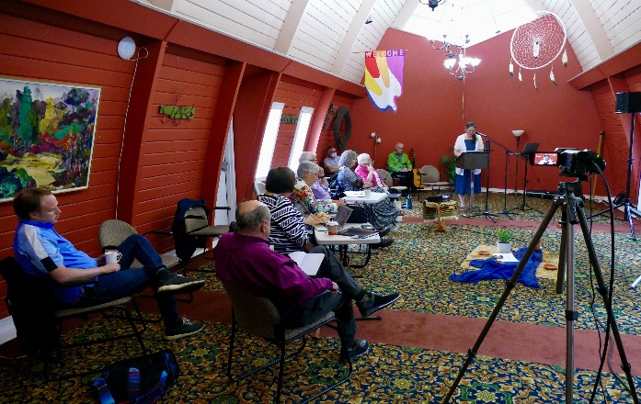

Aurora Living: Spiritual Formation Through Word and Creation
The Star Program Team, Clint Porritt, Sr. Mariangel Marco Teja, UJ, Archbishop Emeritus, Sylvain Lavoie, OMI and Lucie Leduc, developed three modules from Jan to Dec 2022: Wilderness/Exile, Leadership, and Psalms

The second, third and fourth module of nine continued with good attendance and superb facilitators guiding the learning process with online resources to deepen and integrate the knowledge.

Aurora Living provides formation and experiential learning in the Word of God, creation, contemplation, justice, and communion. It leads us more deeply into living a deeply Christian integral ecology in the spirit of Pope Francis’ guidance in his letter, “Laudato Si”.

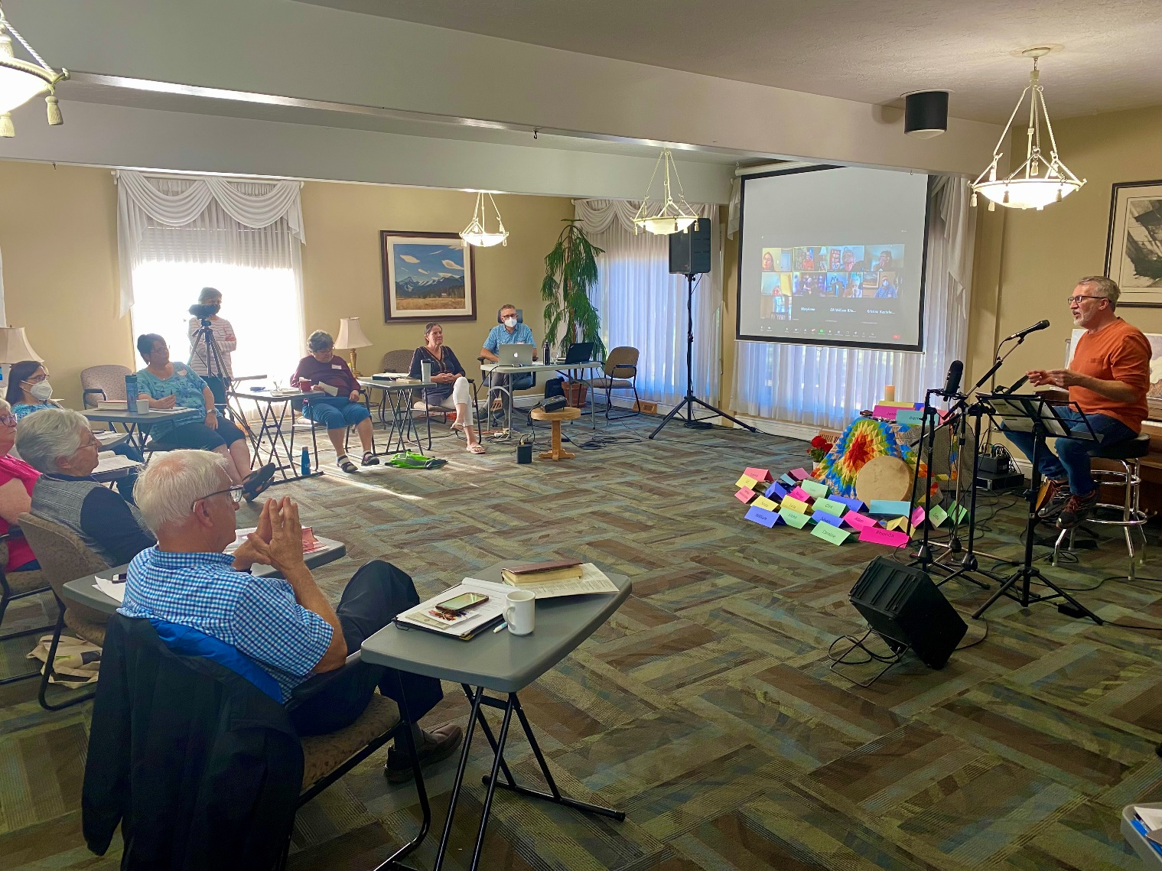

Hosted Facility Programs

- Religious People attending The Star went up from 2021 to 2022 by 21%
- Religious Events went down 16%
- Business People went up 67% Business Events went up 44%
- Spiritual Direction went down 71% Private Retreatants went up 37%

Hosted programs are events planned and booked by independent religious and other groups in agreement with The Star of the North Terms and Policies.

Since the beginning of the pandemic in 2020 and through the various waves that ensued, group usage was down by more than 60% from pre-Covid years. The mainstay for bookings were Studion, Taking Flight International, Franciscans, AMA Impact, Twelve Step groups, yoga groups, Lesley Baartman Reflexology, and others.

One-time events also occurred including Concordia Lutheran Women’s Retreat, Laura Remin Quilting, Harmony in the Workplace, Newman Theological Services, St. Joseph’s College, Saddle Lake Band, The Wilburforce Project, R.H.E.M.A. Church, Ecole Alexandre Tache, Bethel Eritrean Evangelical Church, Conservative Party, Catholic Social Services, Athabasca University, Jesuits of Canada, Archdiocese of Winnipeg, Terwillegar Church retreat, Southwest Community Church, St. Mark Junior High, Joan Kofluk Scrapbooking, Fusion Church, Greater Edmonton Live-In, Foundations in Catholic Leadership, International Healing of Memories, Book clubs and a few others.

Private Retreatants continued to be a growing presence in 2022 while there were fewer bookings for the Spiritual Direction room. Spiritual Directors may have preferred to maintain Zoom or opted to meet elsewhere for meetings.

Fundraising Overview 2022
The Star Board Fundraising Committee, Geneva Lander, Joyce Tutt, , Josee Marr, June Fuller, and Lucie Leduc, organized and executed two fundraisers in 2022: Camino 2022 and Christmas Letter Campaign, and several grant applications. The 2022 capital budget project included replacing 7 carpets in Purple Wing Bedrooms, 3 furnaces in chapel/willow area, and making two suite bathroom repairs. Total of $46,722.23 expended.

Two grant proposal and one matching grant were gratefully received:
1) Grant with M.A.M.I. for 2022 and 2023 programs $10,000
2) Grant with OMI Lacombe Canada - Matching Grant of $20,000,
3) Grant for C.I.P., Community Initiatives Grant with Gov of AB in the amount of $13,800.00

Our events included the Camino, the Christmas letter campaign. The latter is captured in the General Fundraising category. The results were as follows:

A total of $45,833.16 (less GST) was used/expensed for the furnace replacements and renovation project in 2022.

Summary Conclusion
What we see in this past year is a steady growth out of the pandemic and into renewed ministry. Thanks once again to The Star’s committed and generous donor community, and groups slowly returning to The Star for their events, a path of recovery is unfolding into new life.

We are grateful to God for the generosity of volunteer Board Directors, garden and hospitality volunteers who’ve stayed the course with The Star through everything. We give thanks too, to the Oblates of Mary Immaculate for their support and The Star staff for working tirelessly through many transitions and uncertainties. Together we grow thanks to the river of life in Holy Trinity! Thank You!

